**INSTALLATION OF THE ENVIRONMENT FOR USING THE CHATTERBOT**

To start the chat bot of Fatequino on your computer, the following softwares are required:

- MongoDB, version 4.x.x

- Python3, version 3.7.x

- pip, version 19.x.x

# MONGODB

It’s possible to download MongoDB on the official link of the software:

<https://www.mongodb.com/try/download/community>

On the website, choose MongoDB Community Server, and then choose the option from your Operational System. In this example, we’re using Windows. Remember to use the latest version.

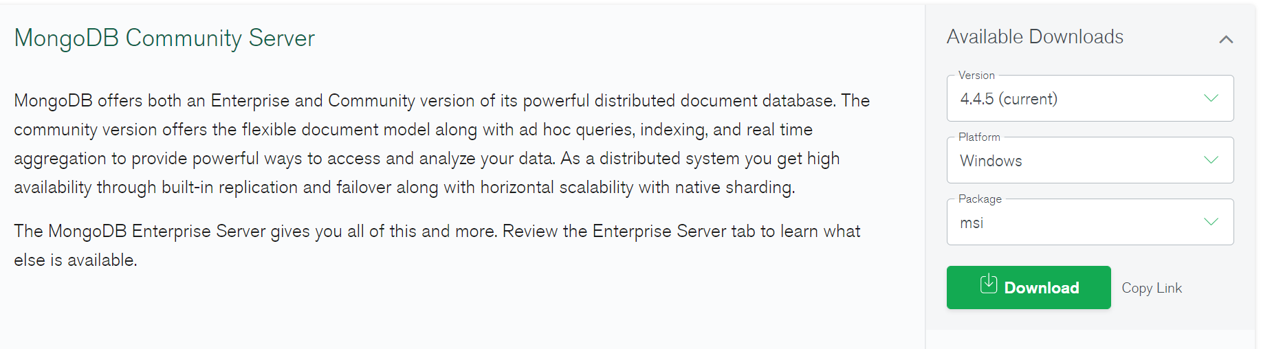

After the download ends, click on the program icon and accept the conditions. Then, choose the Complete option.

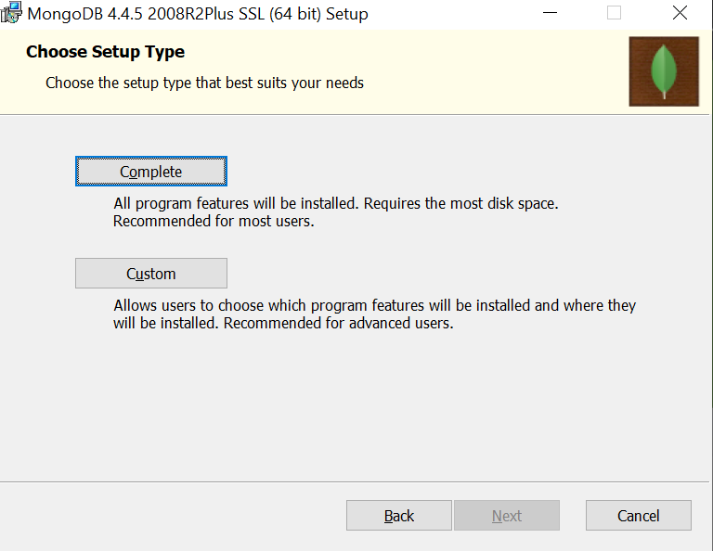

Pay attention to the path MongoDB was installed. In case you didn’t customize the path, the default usually is **Disco Local > Arquivos de Programas > MongoDB > Server > “versão baixada” > bin.**

Inside the folder, there are two files, **mongo** e **mongod.**

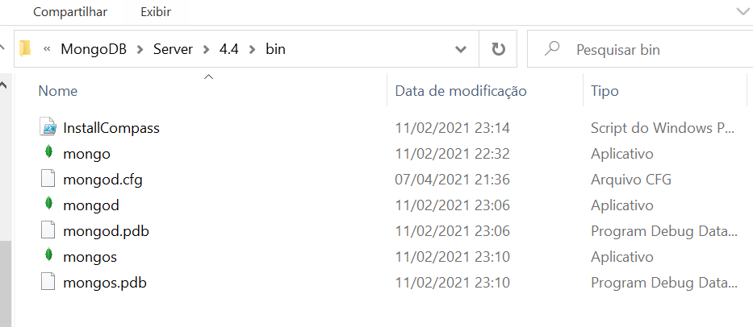

Mongod is a database server, and Mongo is a shell application used to run the command lines for interaction, exclusion or search a specific document on MongoDB database. In order to use it with no problems, we need to create an environment variable.

1. ENVIRONMENT VARIABLES

In case of Windows, you just need to search in the search box “variáveis de ambiente” or you may just go through “Painel de Controle > Sistemas e Segurança > Sistemas > Configurações Avançadas do Sistema”.

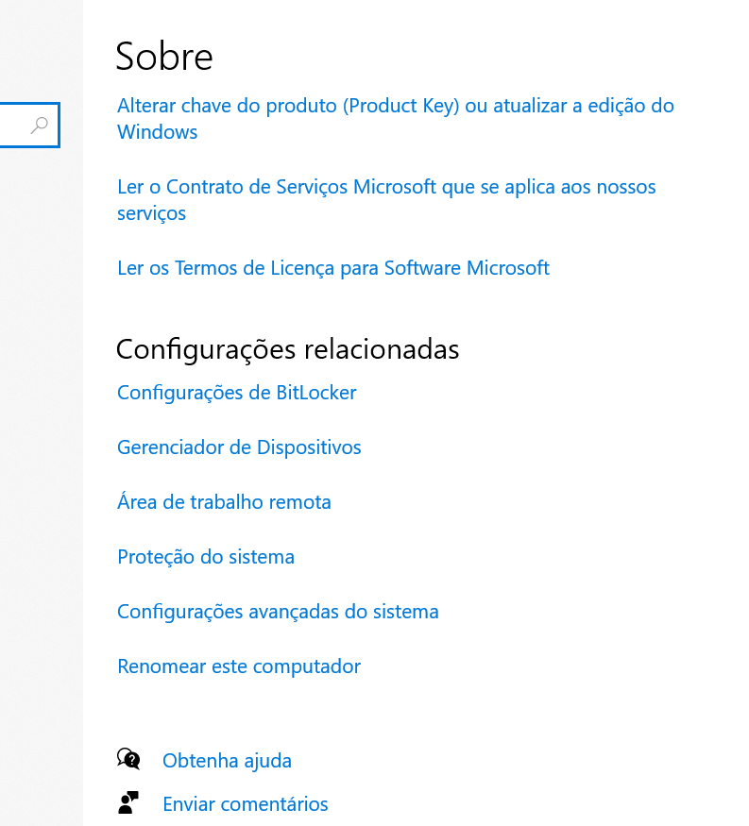

When acessing these configurations, choose the option Variáveis de Ambiente.

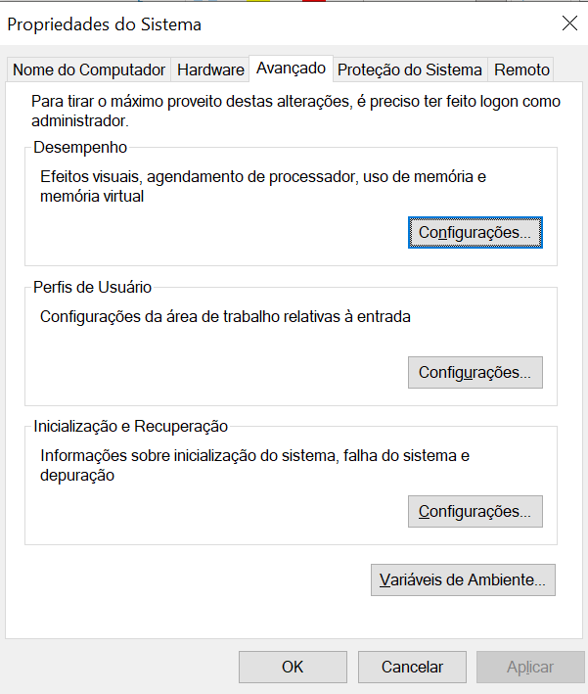

On the new window, there will be two options: variáveis de usuário e variáveis do sistema. The second one is the best option. To not have problems to access it, choose the variable Path, select and edit it.

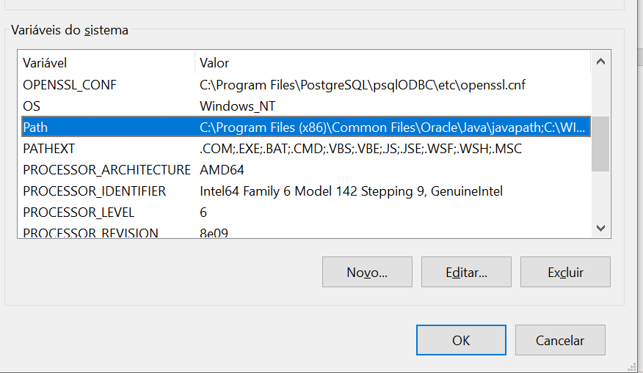

After clicking Editar…, a new window will show up. Then, click Novo.

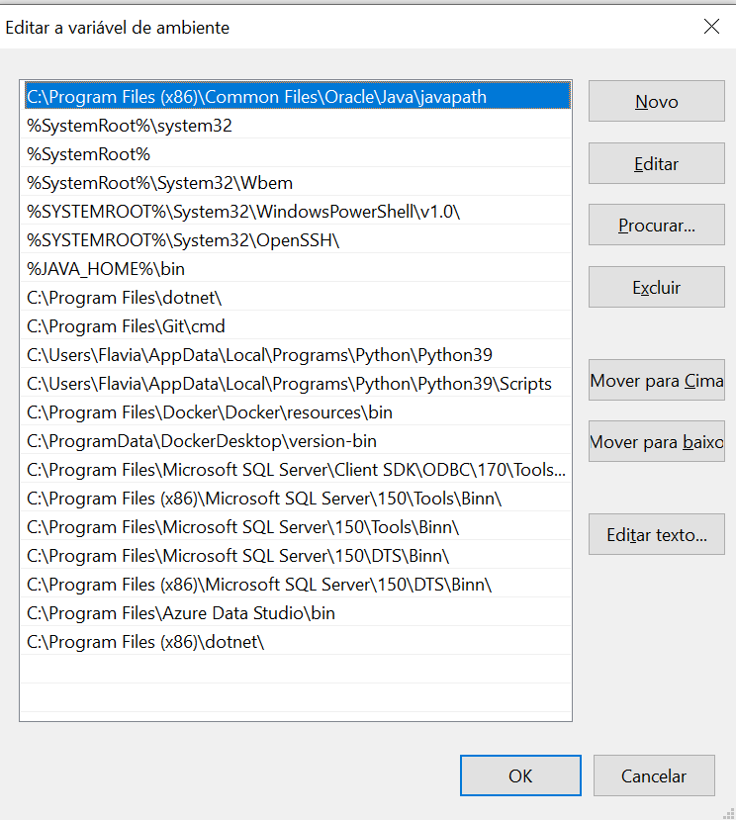

Add the path MongoDB is installed. Usually, the path is: C:\Program Files\MongoDB\Server\4.4\bin.

Remember, “4.4” is the version, so, pay attention to the version you installed.

After inserting the data, click in Ok to save, otherwise, the path won’t be saved.

To find out if the path is correct and working, use the prompt and type mongod -version.

If the version is printed, it’s correct. Otherwise, check if the path and the name of the variable are correct.

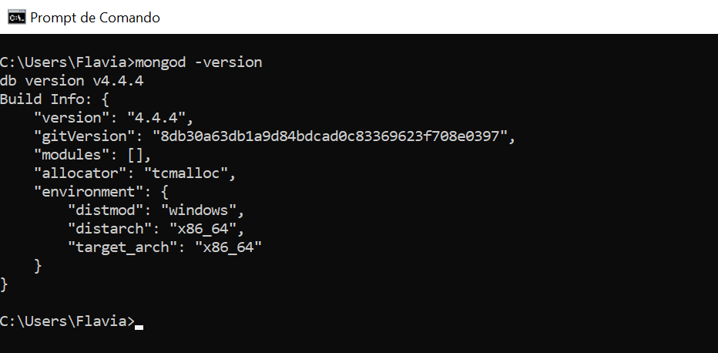

One tip is to open another cmd in case you had used it before creating the environment variable.

After this, we need to launch the database. We just need to run mongod.

In case there is a problem:

exception in initAndListen: 29 Data directory C:\data\db\not found., terminating

It means the computer can not find the directory data. So, we just need o follow the commands:

* cd.. (to go back to the previous directory) run until it goes to “C:\>”;
* md data (creates a directory named data);
* cd data (to move to the directory data);
* md db (creates a directory named db);
* cd db (to move to the directory db)
* mongod (to launch MongoDB)

The window can not be closed, because it would be as if we were shutting down the server.

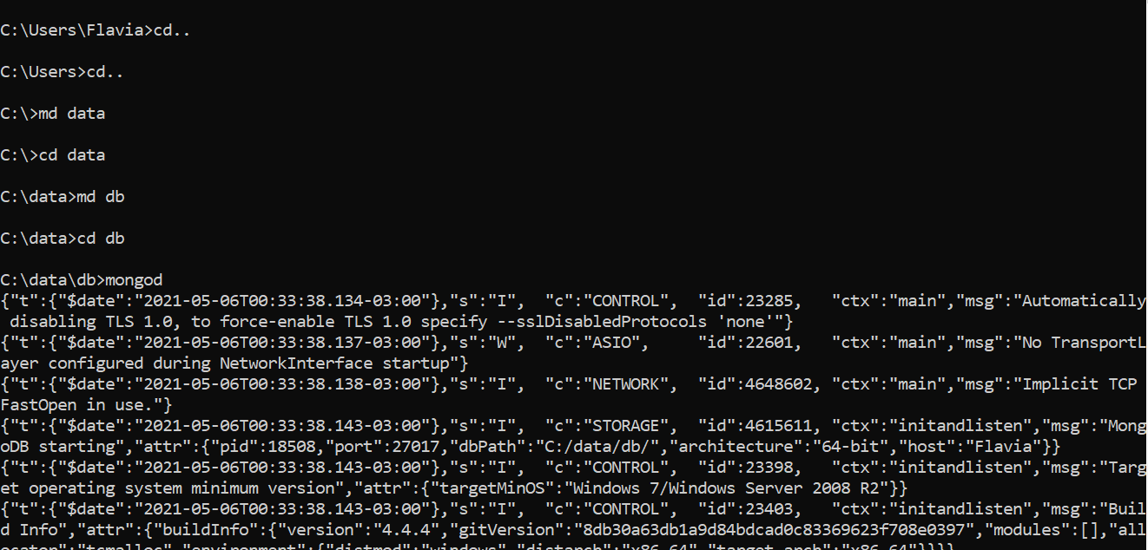

# PYTHON E PIP

To install Python, click on the link below.

<https://www.python.org/downloads/>

Choose the latest version and execute it.

Before clicking Install Now, check the option Add Python to PATH. It will save the trouble of creating and environment variable. If you forgot to check this option, just follow the tutorial at the topic 1.2.

After clicking Install Now, the next window will be Optional Feature, só just let it all as it is (default). On the same window, pay attention to the path Python is being installed. If you didn’t check the option Add Python to PATH, it’s better to copy and paste this path to use later.

After it’s installed, use the prompt to verify if everything went well using the command

python -V

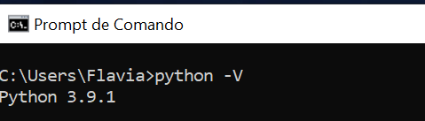

In case it is not printed, check in the environment variables if the path was successfully created.